Risk Profiler Data By: Area Scenario Training Download About Contact

Back to: Scenario Name:

Scenario Catalogue **Mw 9.0 Cascadia Interface**

**$40 billion in loses** | **3,400 Death** | **20,500 buildings damaged beyond repair**

Occupancy of The Buliding ?

Search By Metro Region or Municipality Go or View List

Result for Vancouver x-Clear

Chart

Code Level of the Building ?

Chart

Construction Material ?

Chart

**+**

Legend **-**

Footer

Search

Close

Filter By:

Province

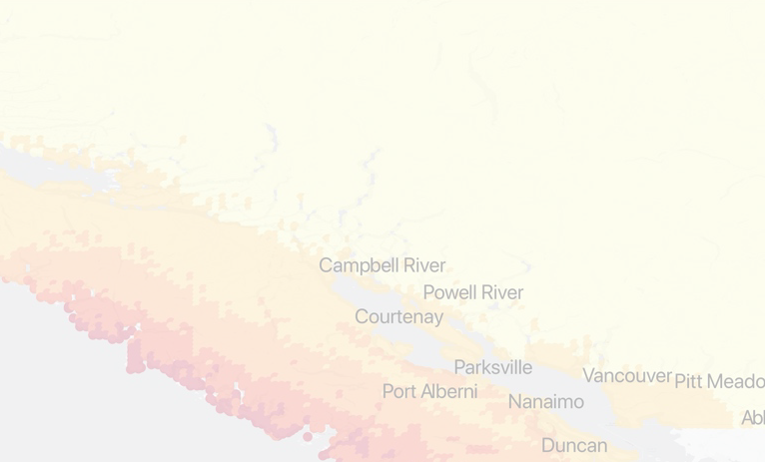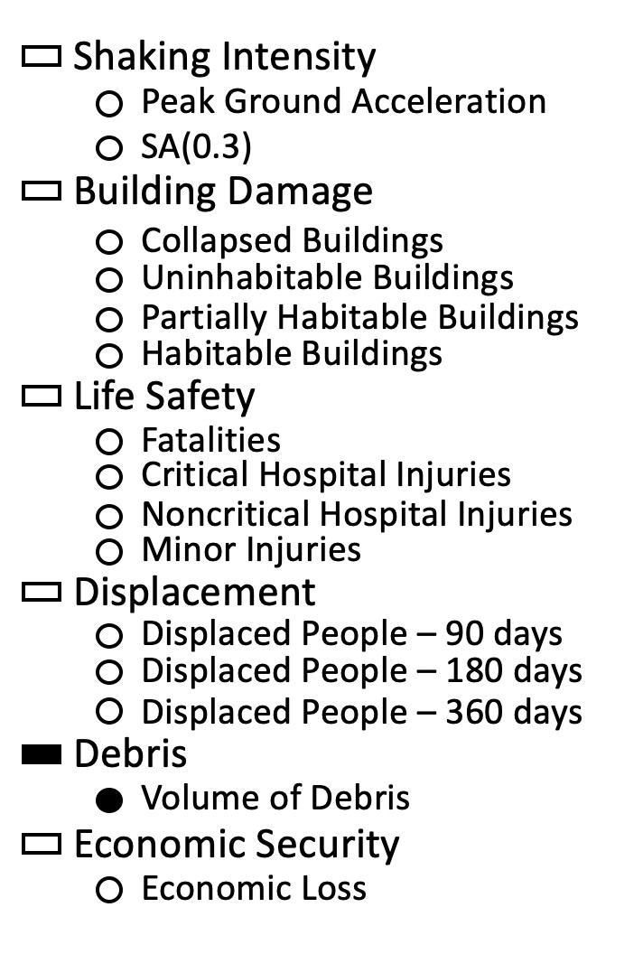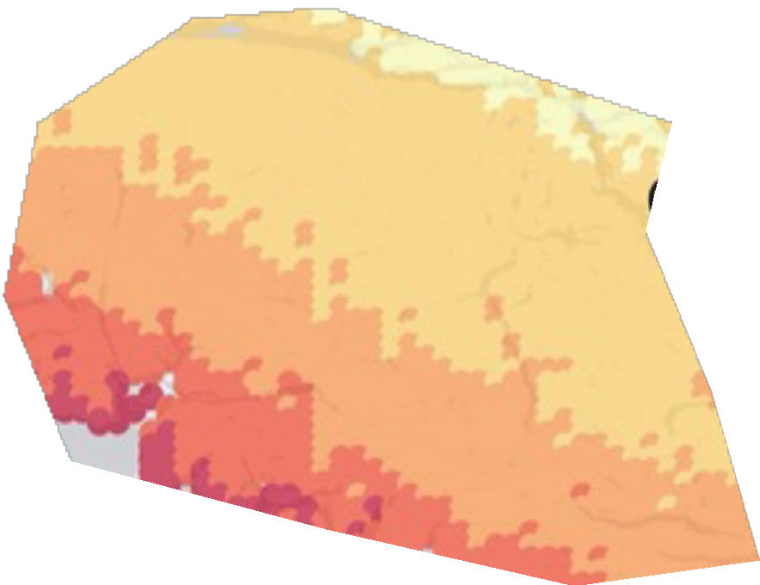

Lorem ipsum doer

Lorem ipsum doer

Lorem ipsum doer

Lorem ipsum doer

Lorem ipsum doer

Lorem ipsum doer

Lorem ipsum doer

Lorem ipsum doer

Lorem ipsum doer

Lorem ipsum doer

Lorem ipsum doer

Lorem ipsum doer

Lorem ipsum doer

Lorem ipsum doer

Lorem ipsum doer

Lorem ipsum doer

Lorem ipsum doer

Lorem ipsum doer

Lorem ipsum doer

Lorem ipsum doer

Lorem ipsum doer

Lorem ipsum doer

Lorem ipsum doer

Lorem ipsum doer

Lorem ipsum doer

Lorem ipsum doer

Lorem ipsum doer

Lorem ipsum doer

Lorem ipsum doer

Lorem ipsum doer

Lorem ipsum doer

Lorem ipsum doer

Lorem ipsum doer

Lorem ipsum doer

Lorem ipsum doer

Lorem ipsum doer

Lorem ipsum doer

Lorem ipsum doer

Lorem ipsum doer

Lorem ipsum doer

Lorem ipsum doer

Lorem ipsum doer

Lorem ipsum doer

Lorem ipsum doer

Lorem ipsum doer

Lorem ipsum doer

Lorem ipsum doer

Lorem ipsum doer

Lorem ipsum doer

Lorem ipsum doer

Lorem ipsum doer

Lorem ipsum doer

Lorem ipsum doer

Lorem ipsum doer

Lorem ipsum doer

Lorem ipsum doer

Lorem ipsum doer

Lorem ipsum doer

Lorem ipsum doer

Lorem ipsum doer

Lorem ipsum doer

Lorem ipsum doer

Lorem ipsum doer

Lorem ipsum doer

Lorem ipsum doer

Lorem ipsum doer

Lorem ipsum doer

Lorem ipsum doer

Lorem ipsum doer

Lorem ipsum doer

Lorem ipsum doer

Lorem ipsum doer





Lorem ipsum doer Lorem ipsum doer

Lorem ipsum doer

Lorem ipsum doer Lorem ipsum doer Lorem ipsum doer

Lorem ipsum doer

Lorem ipsum doer Lorem ipsum doer Lorem ipsum doer Lorem ipsum doer Lorem ipsum doer Lorem ipsum doer Lorem ipsum doer

Lorem ipsum doer Lorem ipsum doer Lorem ipsum doer Lorem ipsum doer